**Lab 2 Part 1 Report**

**Title:** Deal with TIN, DEM, and Time Cube

**Notice:** Dr. Bryan Runck

**Author:** Liang-Ting Chen

**Date:** Mar 4, 2021

**Project Repository:**

<https://github.com/chen6761/GIS5572>

**Abstract**

At first of the lab, I downloaded the .las files from Minnesota DNR’s FTP server, converted them into DEM and TIN, and exported them into PDFs. The process makes me more familiar with the file types and the usage of arcpy in dealing with visualization.

Second, I made a 2D and 3D visualization of .las files in ArcPro to learn how to use the features to work on it. Last, I downloaded the data from PRISM, converted the data into a spacetime cube, and make an animation of the result with arcpy.

**Problem Statement**

In the lab, I plan to visualize the .las files and produce a spacetime cube with arcpy and make a 2D map and 3D scene in ArcPro.

|  |  |  |  |  |  |  |
| --- | --- | --- | --- | --- | --- | --- |
| **#** | **Requirement** | **Defined As** | **Spatial Data** | **Attribute Data** | **Dataset** | **Preparation** |
| 1 | Make TIN and DEM | Raw input from MN DNR | .las files |  | [MN DNR](https://resources.gisdata.mn.gov/pub/data/elevation/lidar/) |  |
| 2 | Make a spacetime cube | Raw input from PRISM | .bil files |  | [PRISM](https://prism.oregonstate.edu/normals/) |  |

**Input Data**

In the lab, I follow the instructor to use .las files from Minnesota DNR and PRISM.

Table. The input data

|  |  |  |  |
| --- | --- | --- | --- |
| **#** | **Title** | **Purpose in Analysis** | **Link to Source** |
| 1 | .las files | Make a DEM and a TIN | [MN DNR](https://resources.gisdata.mn.gov/pub/data/elevation/lidar/) |
| 2 | .bil files | Make a spacetime cube | [PRISM](https://prism.oregonstate.edu/normals/) |

**Methods**

I used beautifulsoup and requests modules to download the .las files from MN DNR. To lower the loading of the CPU, I chose to convert the smallest .las file with arcpy. I used the arcpy.LasDatasetToTin_3d and arcpy.conversion.LasDatasetToRaster to make a TIN and a DEM file. Then, I used arcpy.mp.ArcGISProject to open the project, aprx.listMaps() open a map, .addDataFromPath to add the DEM and TIN I just created, and .exportToPDF to produce the PDFs. In the process, I tried to create a new project with arcpy but failed. After searching for the solution, I found that I need to create a project with GUI then can do the other execution on it. (Tutorial: Getting Started with Arcpy.Mp—ArcGIS Pro | Documentation, 2020)

In the 2D map and 3D scene section, I chose a smaller .las file to present the 3D scene ArcGIS Pro to reduce the execution time. I imported the .las file into one map and used the “Convert” function under the “View” tab. This function can create another map with the same data but in a 3D view. To make the comparison easier, I used the “Link” function to activate the maps centering on the same point. (Figure 1)

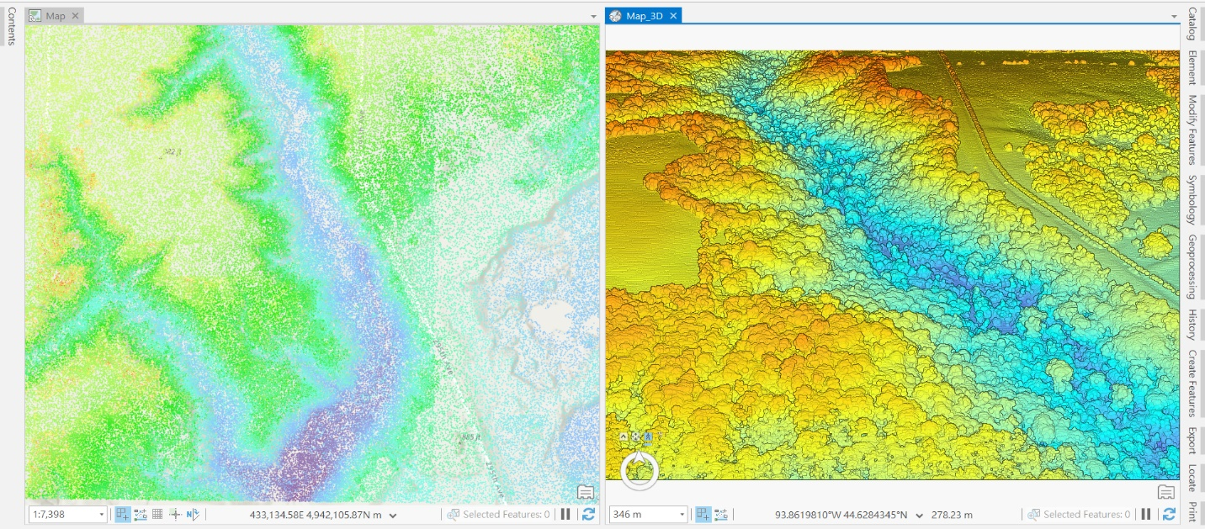

Figure 1

About section 3, I downloaded the data from PRISM. I took its downloading document as a reference to get the data via the requests module. To get all the data once, I set a loop to finish the downloading. For creating a spacetime cube, I executed several steps in arcpy as following.

1. Create the Mosaic Dataset - arcpy.management.CreateMosaicDataset
2. Convert .bil files into TIFF - arcpy.conversion.RasterToOtherFormat
3. Add TIFF into dataset - arcpy.management.AddRastersToMosaicDataset
4. Add the timestamp to the dataset - arcpy.management.CalculateField
5. Build dimensional information - arcpy.md.BuildMultidimensionalInfo
6. Make dimensional raster layer - arcpy.md.MakeMultidimensionalRasterLayer
7. Create spacetime cube - arcpy.stpm.CreateSpaceTimeCubeMDRasterLayer

I also executed the visualize spacetime cube in 3D to present the cube scene (Figure 2), however, I found it ran very slow and could not present as an animation. So, I made layouts for the 2D view of the spacetime cube at different times as preparation to export a visualized animation.

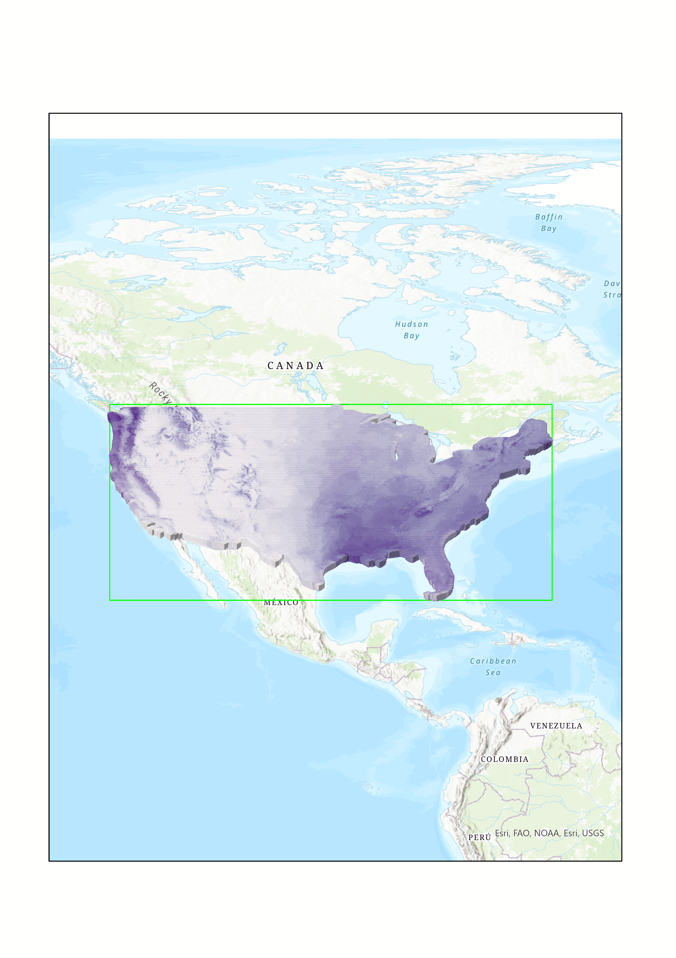

Figure 2

**Results**

I used the .las files to export the PDFs for TIN and DEM in arcpy. (Figure 3)

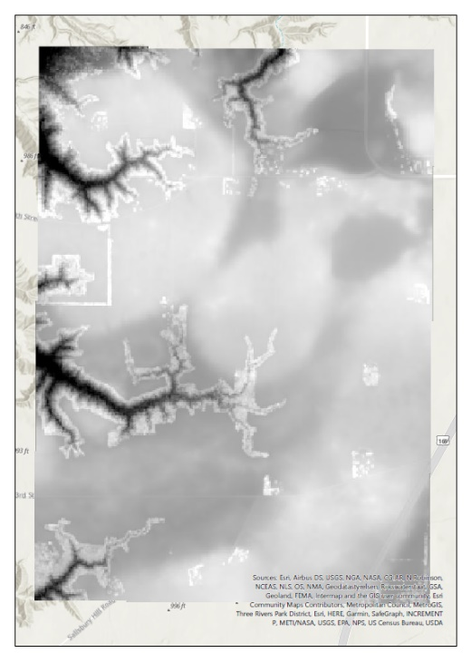 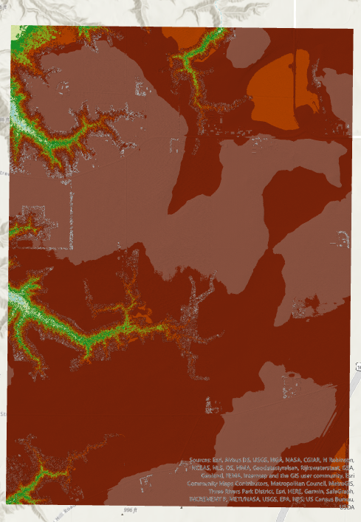

Figure 3

The ArcGIS Pro provides some special features for 3D. First is the navigator, it not only can drag the scene to the four directions and zoom in/out but also can change the aspect angle of elevation. (Figure 4)

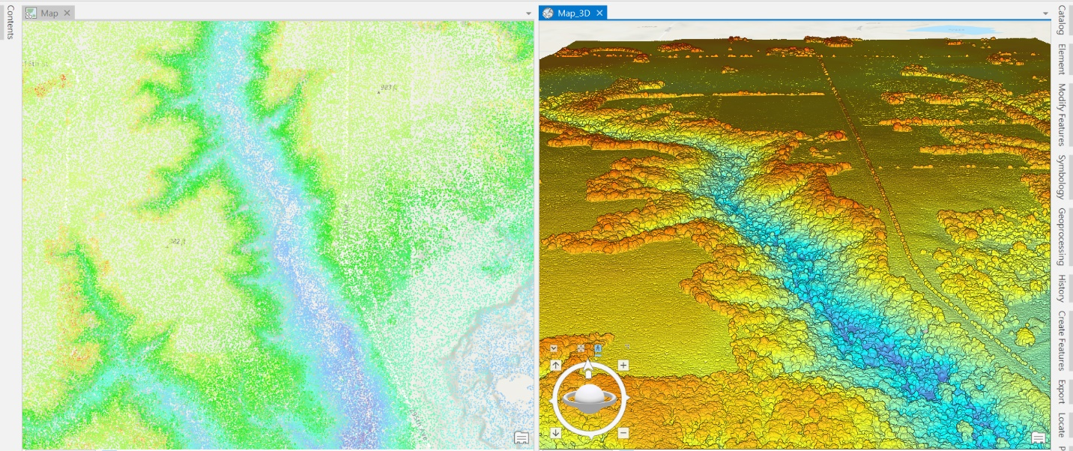

Figure 4

Second, the link function is convenient for users to compare two maps. It makes the maps move together when users drag one of them. (Figure 5)

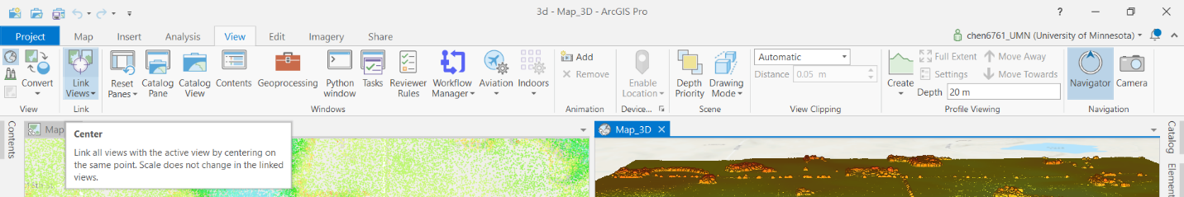

Figure 5

Third, it includes two drawing modes in the 3D scene. One is Perspective, which is useful for realistic representations, the other is Parallel, which is more useful for technical drawing. (Figure 6)

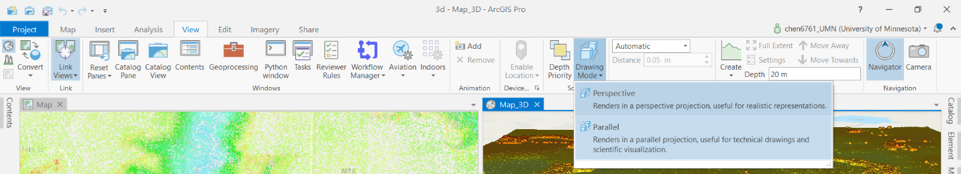

Figure 6

Forth, ArcGIS Pro can also export an animation as a visualization result. The function includes editing the text, creating the path, and modifying the timeline of the video. (Figure 7)

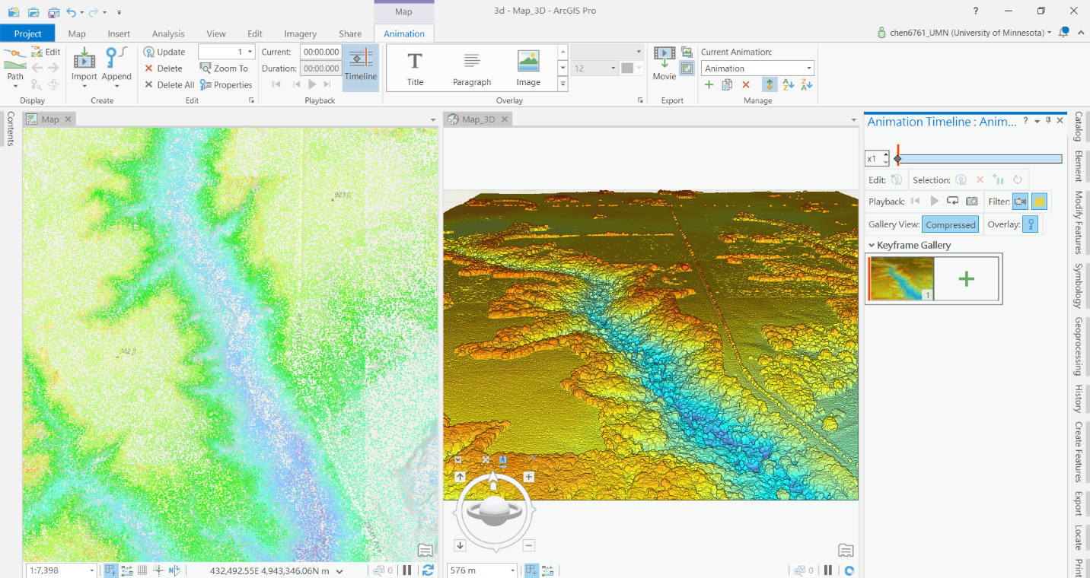

Figure 7

**Results Verification**

About section 1, the TIN and DEM maps are both exported successfully, and the code in arcpy worked without error. About section 2, the 2D and 3D map can be dragged simultaneously, and the scene looks pretty good. About the last section, the .nc file and GIF file are exported to save in the disk, and the animation can be played well to present the time series.

**Discussion and Conclusion**

The lab makes me understand the spacetime cube more, and it is my first time creating one. I met lots of challenges during doing the lab but it worthed. I am thinking about how to reduce the execution time and make the process more efficient. The spacetime cube always takes a long time to execute, I will try to compress or lower the raster data in an acceptable range to improve the efficiency next time.

**References**

Tutorial: Getting started with arcpy.mp—ArcGIS Pro | Documentation. (2020). Esri. https://pro.arcgis.com/en/pro-app/latest/arcpy/mapping/tutorial-getting-started-with-arcpy-mp.htm

**Self-score**

|  |  |  |  |
| --- | --- | --- | --- |
| **Category** | **Description** | **Points Possible** | **Score** |
| **Structural Elements** | All elements of a lab report are included **(2 points each)**:  Title, Notice: Dr. Bryan Runck, Author, Project Repository, Date, Abstract, Problem Statement, Input Data w/ tables, Methods w/ Data, Flow Diagrams, Results, Results Verification, Discussion and Conclusion, References in common format, Self-score | 28 | 28 |
| **Clarity of Content** | Each element above is executed at a professional level so that someone can understand the goal, data, methods, results, and their validity and implications in a 5 minute reading at a cursory-level, and in a 30 minute meeting at a deep level **(12 points)**. There is a clear connection from data to results to discussion and conclusion **(12 points)**. | 24 | 22 |
| **Reproducibility** | Results are completely reproducible by someone with basic GIS training. There is no ambiguity in data flow or rationale for data operations. Every step is documented and justified. | 28 | 26 |
| **Verification** | Results are correct in that they have been verified in comparison to some standards. The standard is clearly stated **(10 points)**, the method of comparison is clearly stated **(5 points)**, and the result of verification is clearly stated **(5 points)**. | 20 | 18 |
|  |  | 100 | 94 |